- There are some terminologies in AOP which are Aspect, Advice, Join Point, Point cut, Proxy .
- Understanding these terms:
  - Lets assume you have some methods where you want to add some cross-cutting logic.
    - Cross-cutting logic refers to any secondary code apart from business logic.
    - For example: logging, transactions , security etc etc.
  - Some secondary logic needs to be executed before / after / around the execution of these methods.
    - These methods execution is called Join Points.
    - Method definition is not Join Point; Method execution is Join Point.
  - Since many methods can be executed, all these method executions are Join Points.
  - You usually do not want to apply cross-cutting logic to all join points, so you need, a filtering logic is required to select some of those.
    - This filtering logic is called a Pointcut.
  - A Pointcut defines which join points should be selected for applying cross-cutting logic.
  - The code that has to be executed along with the selected join points, and the timing of its execution, together form an Advice
  - Advice defines:
    - What code to execute (cross-cutting logic)
    - When to execute it (e.g., @Before, @After, @Around, etc.)
  - The class that contains all the advice methods is called Aspect.

- Proxy
- In spring, when you create a bean of a class, Spring doesn’t assign the object of that exact class; rather it assign an object of the proxy of that class (proxy class extends the real class).
- Lets say this is your real class:
  - 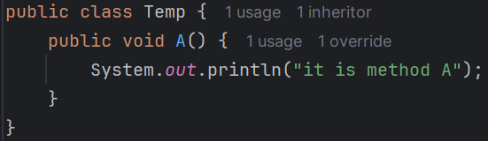
- When you write @Autowired or @Configuration, @Bean or anything to get a bean of that class, you’ll get a bean of a class of following type:
  - 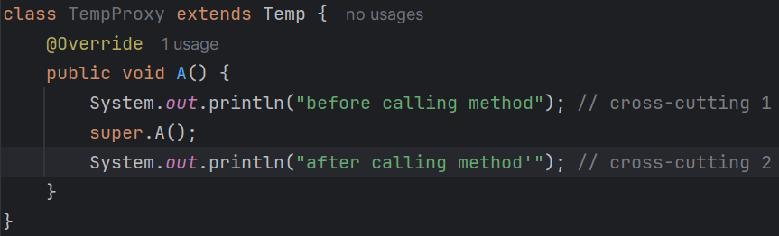
  - This overridden method will be containing all the cross cutting logic and call the real method (its parent class which is real class)
- Consider the below scenario:
  - 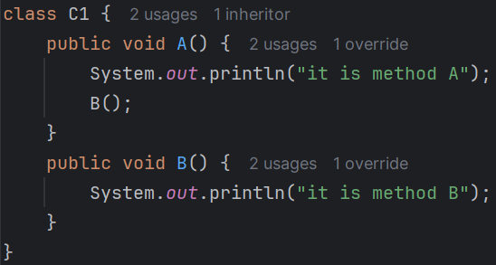
    - Here I am calling B() inside the method A() in the real class.
  - 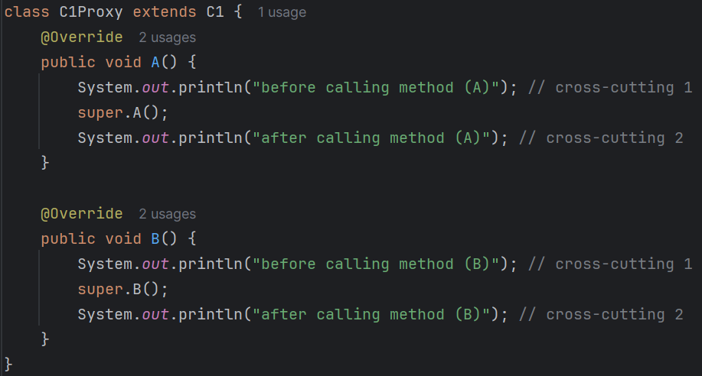
    - It will be proxy class which object will be assigned to your variable.
  - Now lets say you call proxyObject.A() then what will happen? In plain Java
    - proxyObject.A() -------------------- C1Proxy’s A()
    - super.A() -------------------- C1’s A()
    - this.B() --------------------- C1Proxy’s B()
  - Here the output will be proper:
    - 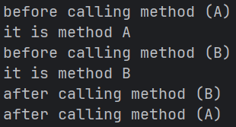 (output)
    - Because here this will refer to the object type only which is of type C1Proxy.
- In case of Spring AOP, the below happens:
  - 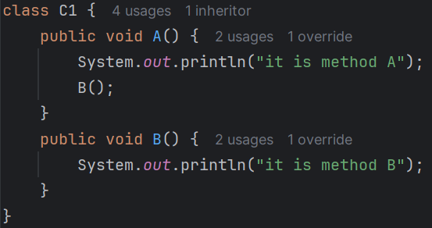
    - It is the real class C1.
  - 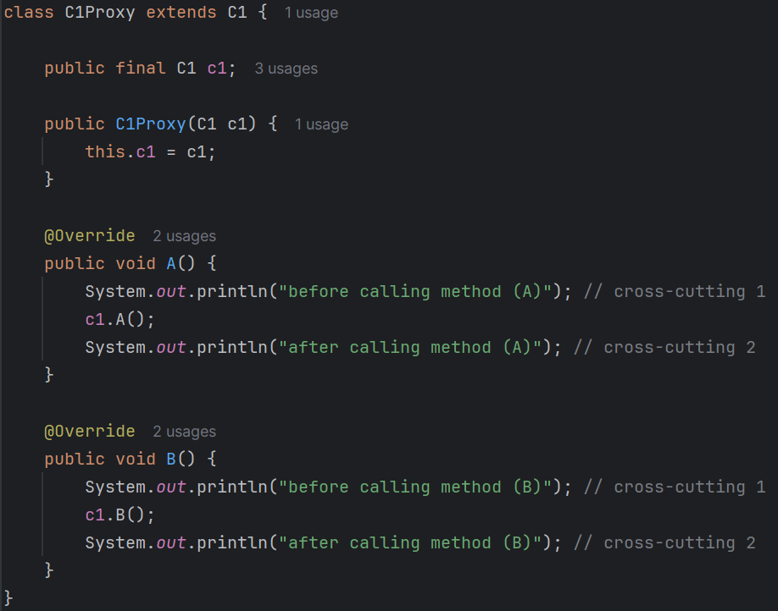
    - It is the proxy class C1Proxy.
    - But it doesn’t extend the real class, rather it keeps one object of the real class.
  - Now lets say you call proxyObject.A() then what will happen? In plain Spring AOP
    - 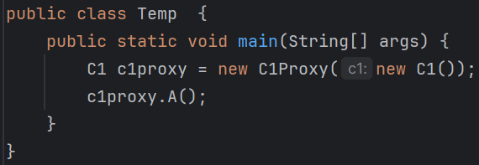
    - c1Proxy.A() -------------------- C1Proxy’s A()
    - super.A() --------------------- C1’s A()
    - this.B() --------------------- C1’s B()
      - Because here public final C1 c1; is the real class’s object which is C1.
  - In our code, Proxy is a proper class (TempProxy) that extends the real class (Temp),
  - This is why, calling one method (present inside the same class) from another method will not work in case of AOP.
- The below is a simple template of spring AOP syntax
  - 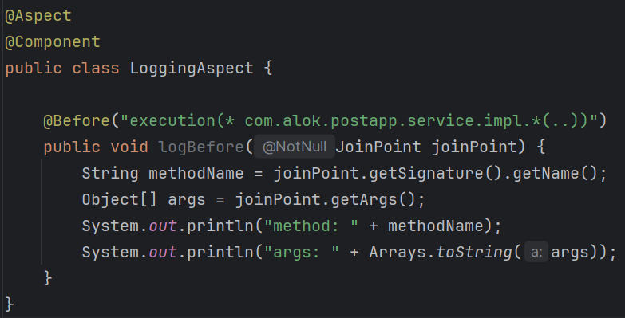
  - LoggingAspect class → Aspect
  - @Before + content of logBefore method → Advice
  - “execution(……)” → Pointcut
  - Method execution matched by the pointcut → Join Point
  - Aspect contains Advice, Advice uses Pointcut, Pointcut selects Join Points
- JoinPoint and ProceedingJoinPoint
  - You can get an object of type JoinPoint to get the details about the method (join point)
  - For the advice type @Around, you can get ProceedingJoinPoint which contains the features of JoinPoint + some extra features.
  - JoinPoint is kind of observer which can get the details about the method and all, but ProceedingJoinPoint can control the method execution and all.
  - ProceedingJoinPoint is only valid in case of @Around advice type.

- NOTE
- Difference between .. and .*
  - com.xyz..service.*.*(..) and com.xyz.*.service.*.*(..)
  - These both looks same but they are not.
  - com.xyz..service.*.*(..) means it matches any number of sub-package levels.
    - com.xyz.service
    - com.xyz.user.service
    - com.xyz.user.order.service
    - com.xyz.a.b.c.service
  - com.xyz.*.service.*.*(..) means it matches only one sub-package level.
    - com.xyz.user.service
    - com.xyz.order.service
    - com.xyz.admin.serviceﺀ
    - com.xyz.user.order.service ❌ IT’LL NOT MATCH

Dynamic Proxies
- In pure Java, whatever you call from a object, it gets called inside that object only. There is no involvement of any proxy by default. But you can create proxy and use it.
- JDK Dynamic Proxy
- It is a proxy built into Java itself that works only with interfaces.
- No interface → no JDK dynamic proxy
- Java cannot modify existing classes at run-time, but it can generate a new class implementing the same interface at run-time.
- Steps to create custom proxy in Pure Java
  - 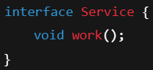 (real interface)
  - 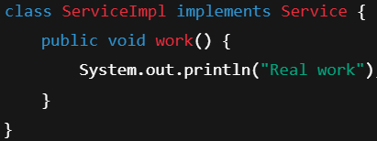 (real class)
  - 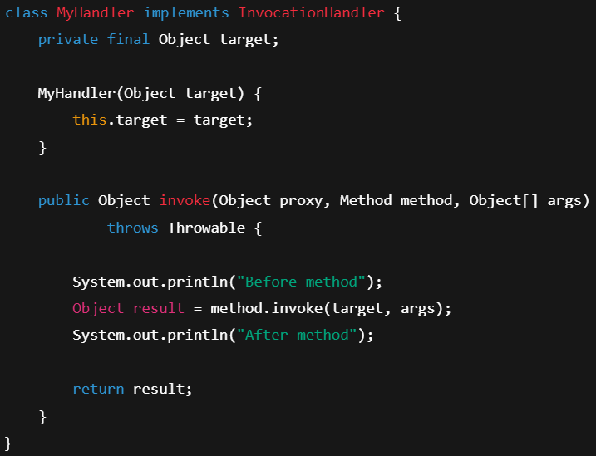(self created handler: it’s the main thing)
    - This is where interception happens.
    - method.invoke(target, args) -- it means call the method inside the target with the arguments args.
  - 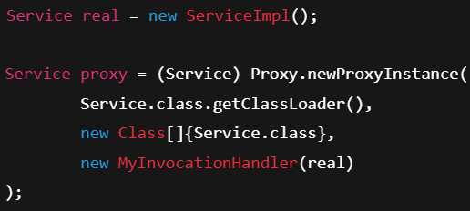 (create proxy)
  - (now call the method)
  - At run-time, Java creates something like this:
    - 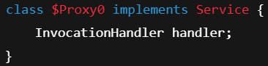
  - if you want to get a proxy object then you have to use Proxy.newProxyInstance only, if you use new keyword to create an object then you’ll get a real object only, not an proxy object. ----- in Pure Java; not Spring
  - This is the flow:
    - 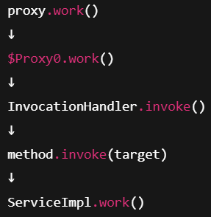
    - proxy object’s method call will lead to InvocationHandler’s invoke method call which do pre & post execution of the actual method call.
- CGLIB Proxy
- CGLIB is not a Pure Java feature; it works if you add the CGLIB library or use any framework like Spring, Hibernate …etc.
  - 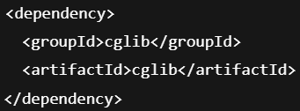
- It works even if there is no interface involved.
- Steps:
  - Create one interceptor class
    - 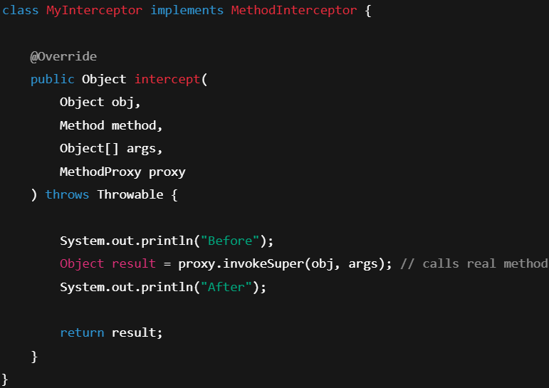
  - Create CGLIB proxy
    - 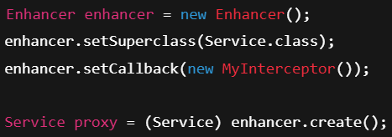
  - In run-time, CGLIB will create something like this:
    - 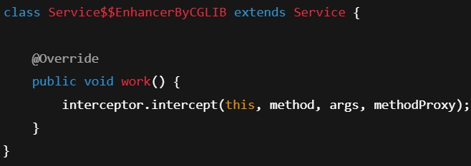
  - When you call proxy.work() the below flow happens
    - 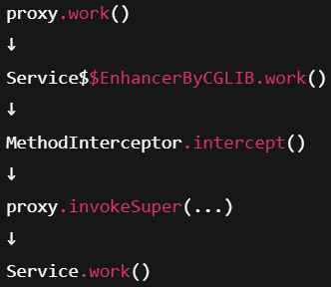
- Proxy used by Spring AOP
- Spring AOP uses JDK Dynamic Proxy if an interface exists; otherwise it uses CGLIB (or always CGLIB if forced).
Pointcut
- execution pointcut
- If you don’t give any reference to the method in the Pointcut statement, then it’ll select all the method having that name in all the directories.
  - Now, all the methods present having name orderPackage() throughout the directories, will be selected.
- If you write the full reference then only that specific method present in that reference will be selected.
- You can also loose the reference by giving * in between.
  - All the orderPackage() methods inside all the classes inside impl package will be selected.
- See the below:
  - 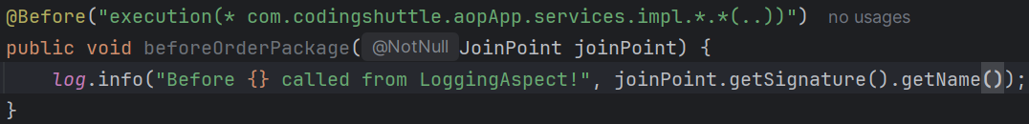
  - Here all method present inside all the classes present inside impl package will be selected.
- You can also get the kind of join point
  - 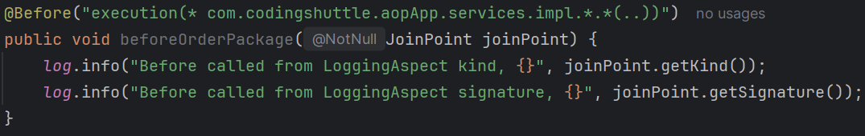

- within pointcut
- Description
  - Use within when you want to limit the advice to a particular class or package, without focusing on specific methods.
  - This pointcut applies to any join point within the a package like com.example.aopApp.services package, including methods, fields, and constructors.
  - It’ll apply to all the classes present inside impl package.
- @annotation pointcut
- It is used to apply advice to methods annotated with a particular annotation.
- You can also create your own custom annotation and apply advice to the methods which use your custom annotation.
  - It’ll apply advice to all the methods annotated with @Transactional annotation.
- Using custom annotation for advice
  - I created one custom logging annotation:
    - 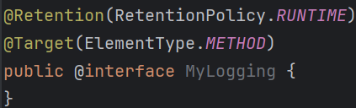
  - Now use this annotation in the pointcut
    - 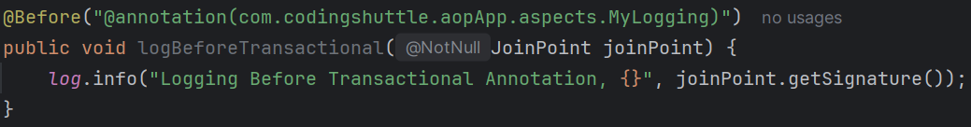
- Also you can combine multiple pointcuts with && or || operators.
  - 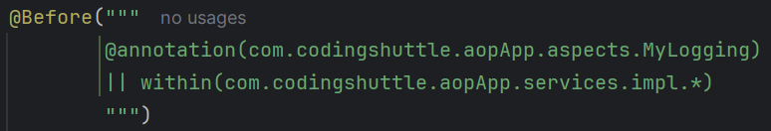

- Using @Pointcut to declare a pointcut expression and re-use that multiple times.
  - I created a pointcut rule
    - 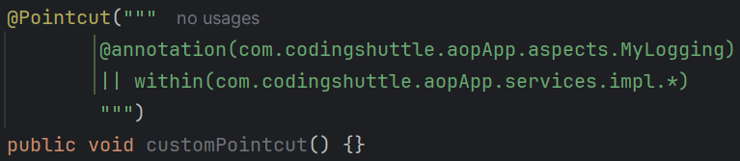
  - Now just use it like this
    - 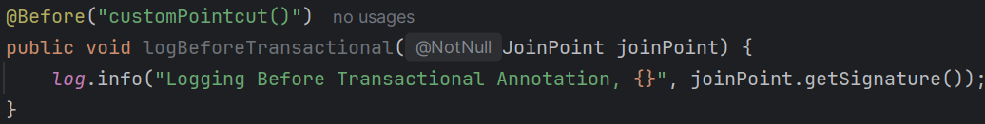
    - If you want to apply multiple types of advices like @Before, @After ..etc to a same pointcut expression, then it is useful, because you don’t need to write it again and again.
  - @Pointcut methods are never executed; they only name a pointcut expression used by advice.
    - Even if you write something in that pointcut method (customPointcut() in our case), it’ll never be executed.

Advice
- Advice is associated with a pointcut expression and runs before, after, or around method executions matched by the pointcut
The pointcut expression may be either an inline pointcut or a reference to a named pointcut.
- There are the following advice types
  - @Before
  - @After
  - @AfterReturning
    - 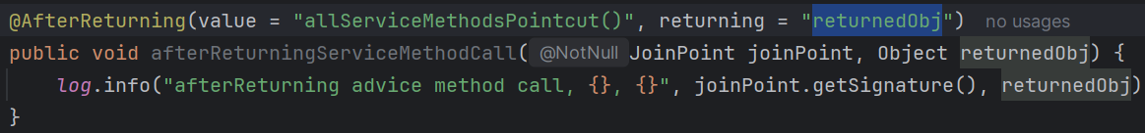
    - If you want to get the returned object, then use like this.
    - The name against returning should be same as the argument name inside the advice method. Argument should be of type Object.
  - @AfterThrowing
    - 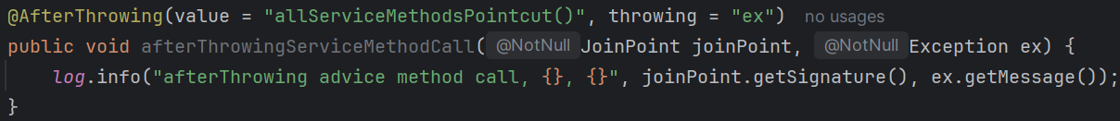
    - Here also, if you want to get the thrown exception, then use like this.
    - The name against throwing should be same as the argument name for exception inside the advice method.
  - @Around
    - It has complete control over the method, either to run that, or do something before or after that.
    - 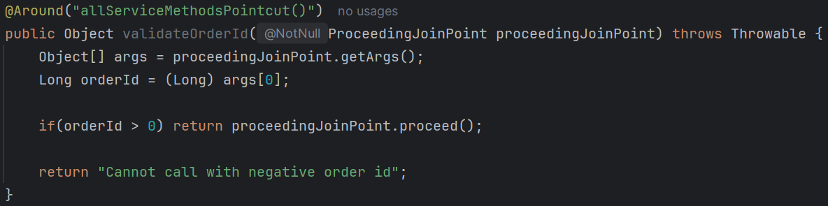
      - You can do validation in this as well.
      - Use ProceedingJoinPoint in case of @Around to get more control.

Spring Proxy & Internal Working of AOP
- Spring Proxy
  - Proxies are created only when certain conditions are met, such as when
    - AOP is enabled, and there are pointcuts matching specific methods.
    - Spring features like @Transactional, @Cacheable, and @Async are used, which internally rely on proxies to apply cross-cutting concerns like transaction management, caching, or asynchronous method execution.
  - If a Spring bean doesn’t need any cross-cutting functionality (like AOP, transaction management, caching or async processing), no proxy will be created.
Spring optimizes its proxy creation to avoid unnecessary overhead when proxies are not needed.
- How Proxies are managed?
  - Proxies are created and managed by the Spring container (the ApplicationContext).
When Spring determines that a bean needs to be proxied (due to AOP advice, transaction management, caching, etc..), it creates a proxy for the bean instead of instantiating the bean directly.
    - This proxy wraps around the actual bean and adds additional behaviour (advice) before and after the actual method calls.
    - Thus, proxies are stored in place of the actual beans in the ApplicationContext.
Whenever a client retrieves a bean (e.g., via @Autowired or context.getBean()), what they receive is the proxy object, if proxying is enabled for that bean.
- How Proxy are created?
  - Spring AOP typically relies on dynamic proxies (JDK Dynamic Proxies or CGLIB Proxies) to implement the interception of method calls.
    - JDK Dynamic Proxies
If the target object implements one or more interfaces, Spring uses JDK Dynamic Proxies.
The proxy is created at runtime, implementing the same interfaces as the target object.
    - CGLIB Proxies (Code Generation Library Proxies)
If the target object doesn’t implement any interfaces, Spring uses CGLIB, which generates a subclass of the target class at runtime to create the proxy.
  - When a method on the proxy object is called, the proxy intercepts the method call and applies the advice around it.
- How Proxies are used?
  - When Spring starts up, it scans the classes for aspects and applies the advice to the relevant beans based on the pointcuts.
  - For each bean, Spring determines whether it needs to be proxied (based on whether any methods match a pointcut).
  - If proxying is needed, Spring creates a proxy object that wraps the original bean.
  - When a client calls a method on the proxied bean, the call is intercepted by the proxy.
The proxy determines if there is any advice that should be applied based on the pointcuts.
  - If the method does not match any pointcuts, the proxy delegates the call directly to the target object without applying any advice.
  - If advice exists, the proxy executes the advice (e.g., logging, transaction management) before, after, or around the actual method invocation.
  - The most powerful type of advice is @Around.
It allows you to control the execution of the target method by calling ProceedingJoinPoint.proceed()
You can choose to execute code before and after the target method execution or even decide not to execute it at all.
  - After the advice has been executed, control is returned to the original method.
  - Any results returned by the method or exceptions thrown are then passed back to the caller.
- Weaving
  - In addition to dynamic proxies, Spring AOP can use a process called weaving for bytecode manipulation.
Weaving is the process of injecting aspects into the target class bytecode at different points in the lifecycle.
    - Compile-time weaving:
Aspects are woven into the code during the compilation process.
    - Load-time weaving:
Aspects are woven when the class is loaded into the JVM.
    - Post-compilation weaving:
Aspects are woven after the classes have been compiled.
  - Spring primarily uses dynamic proxies, but with AspectJ integration, load-time weaving or compile-time weaving can also be used for more complex scenarios.
- F

